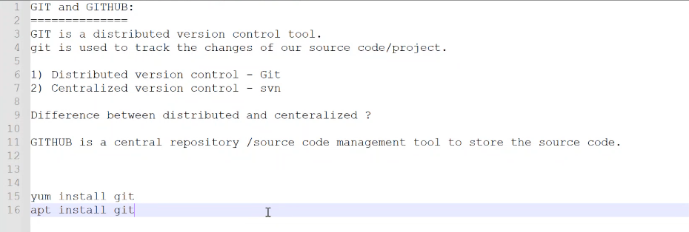

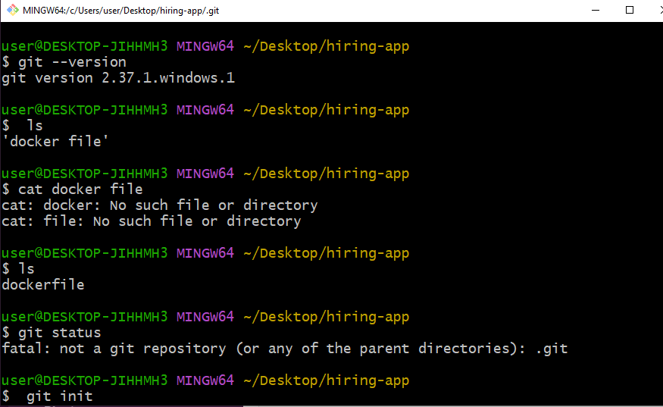

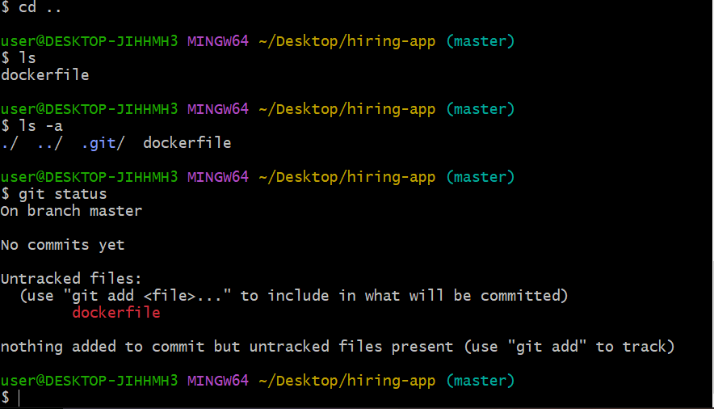

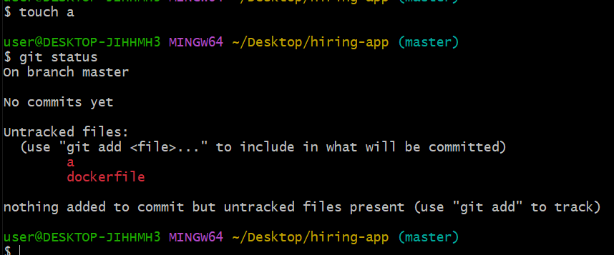

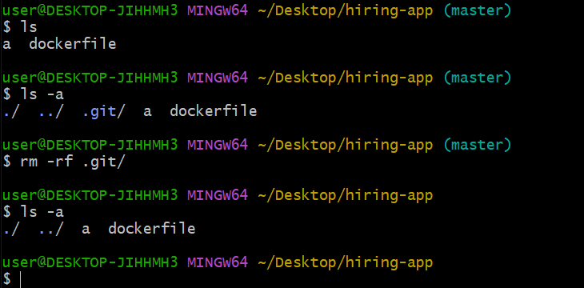

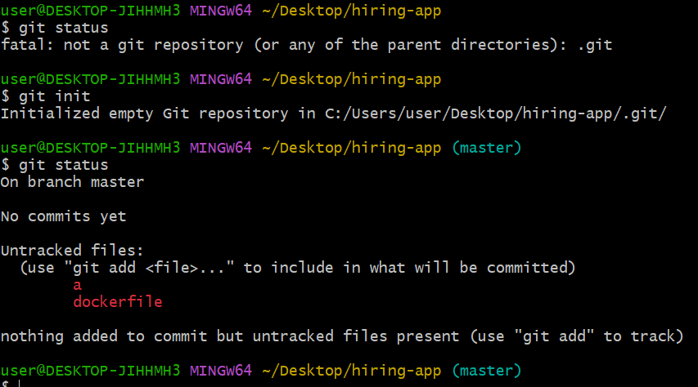

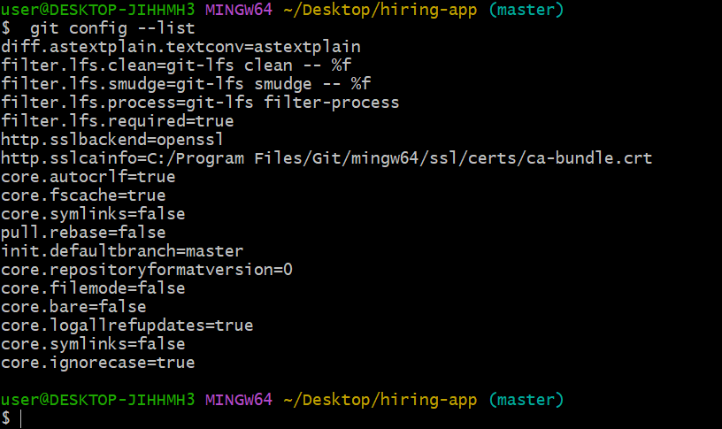

Inorder to configure username and email id

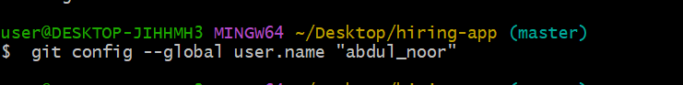

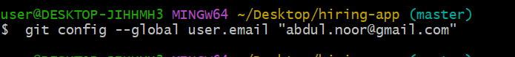

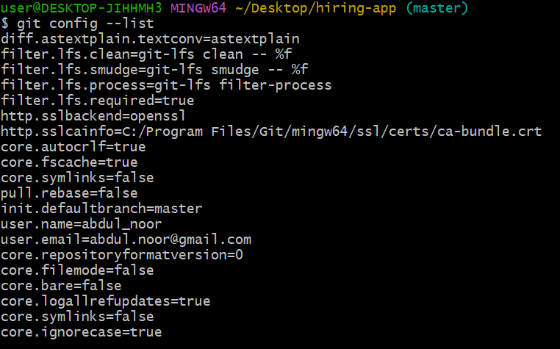

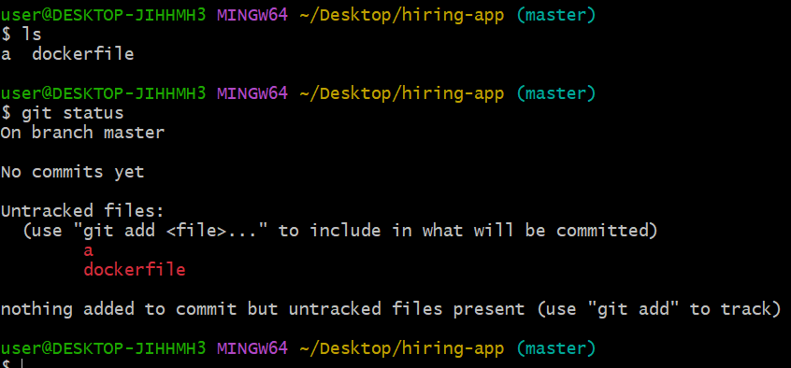

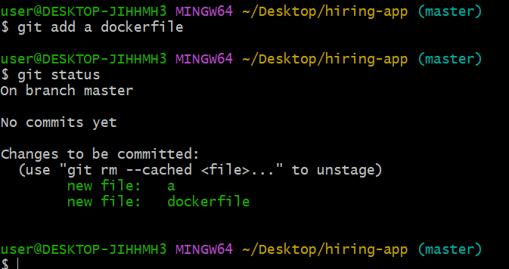

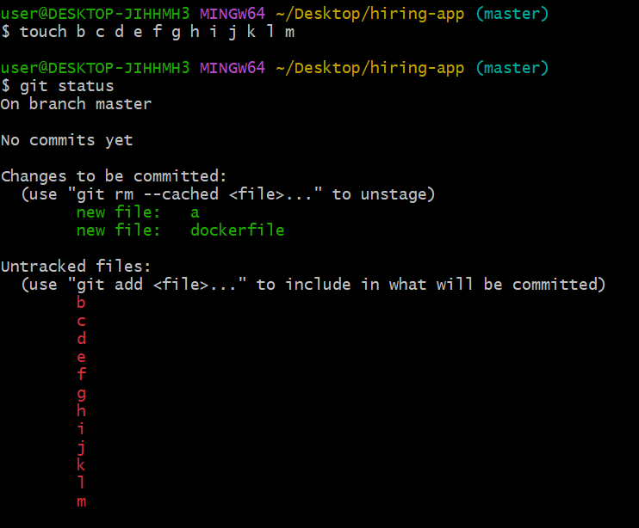

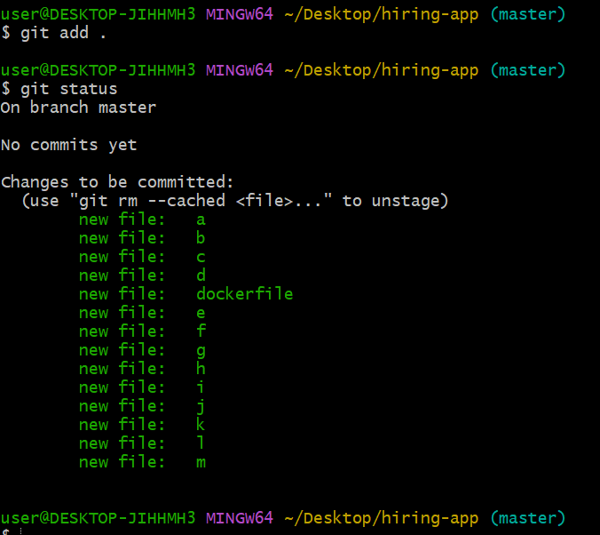

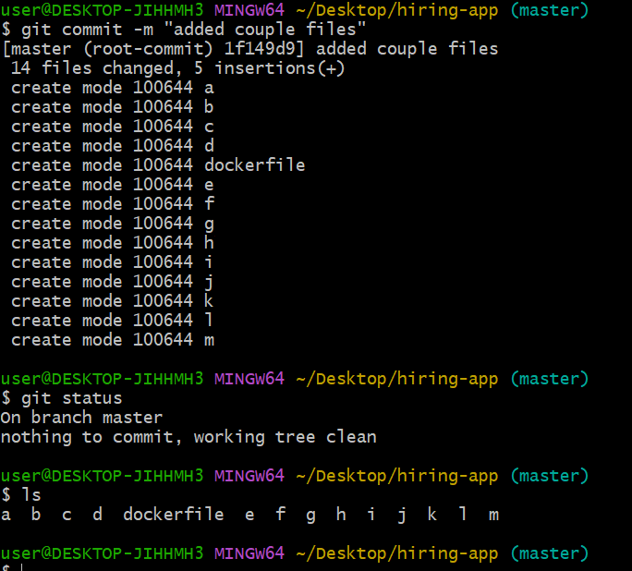

Whatever changes did everything is stored in git log

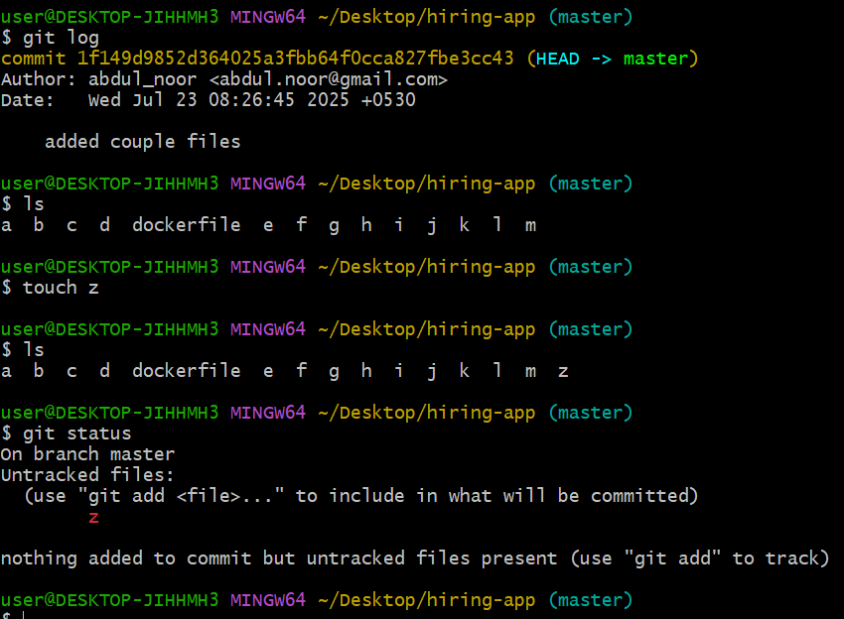

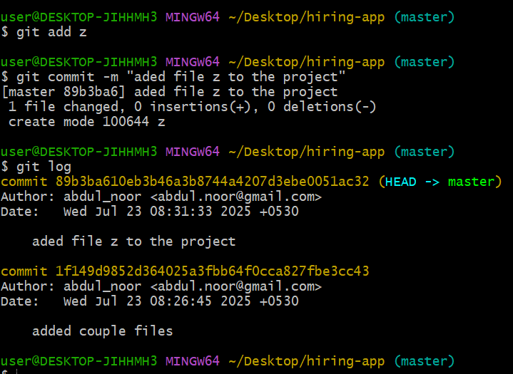

See in the above showing two different commit id’s

Now our task is move all the changes stored in the central repository currently I am in my local machine.

Now use GITHUB

Create account as your first time using

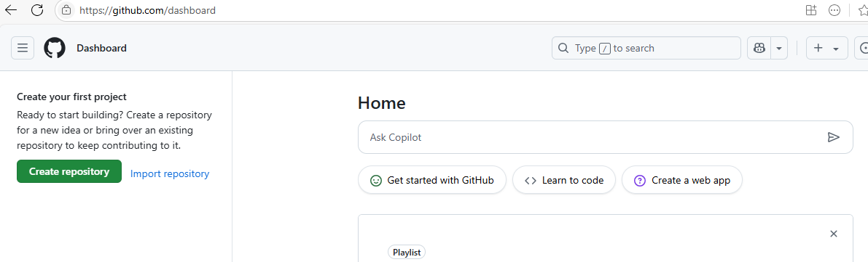

Now I want all the changes to my CR for that command

To push to particular location in CR I should add add the address url over here while executing command git push url

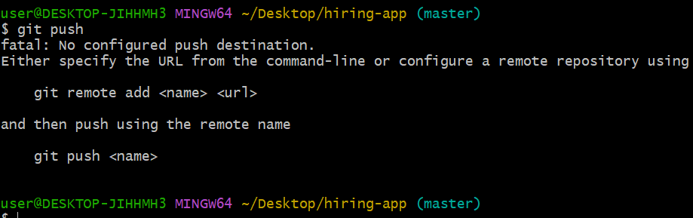

No configured PD

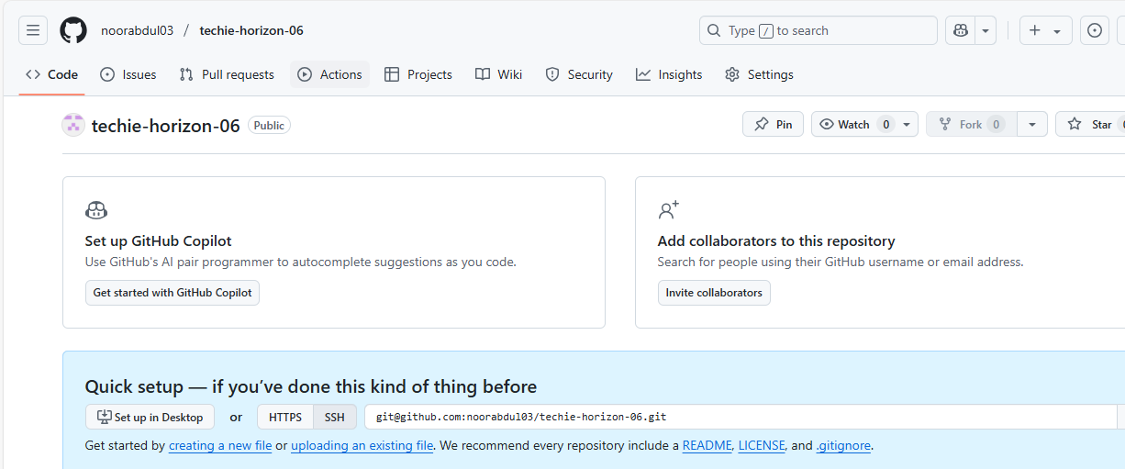

Beore this to see I any addresses already configured

Command

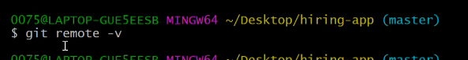

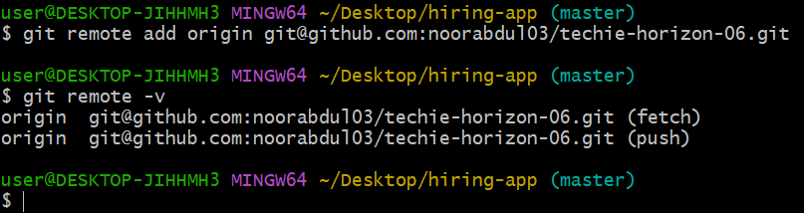

Before pushing I need to have the connectivity rom machine to CR

You can use git push or git push –u origin master

See what happens

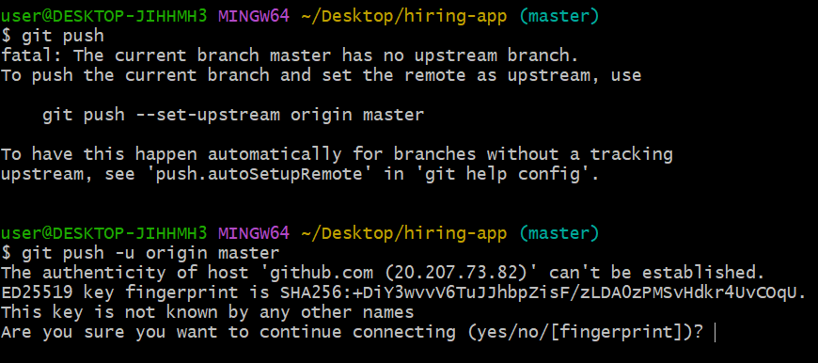

And it is telling permission denied

Because of authentication so need to provide

First need to generate SSH key

Ssh-keygen

/c/Users/user/.ssh/id_rsa

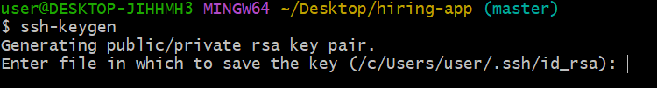

Enter enter enter

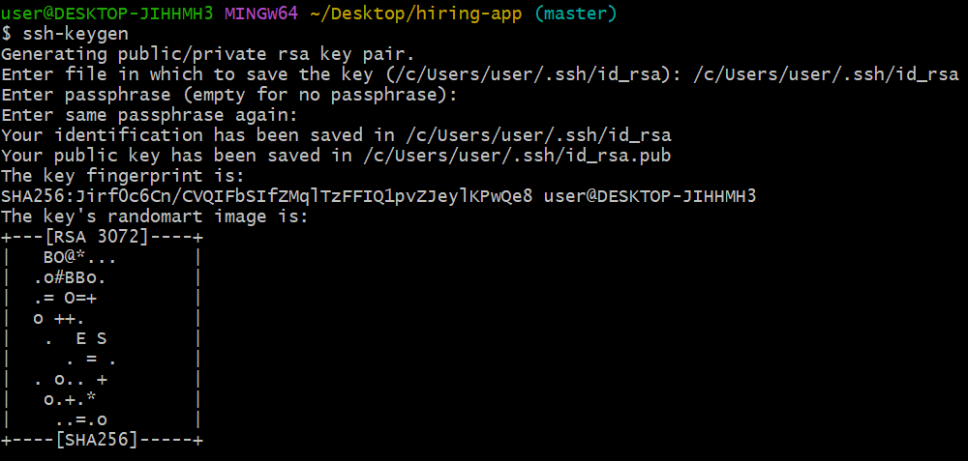

One key has been generated public key

/c/Users/user/.ssh/id_rsa.pub

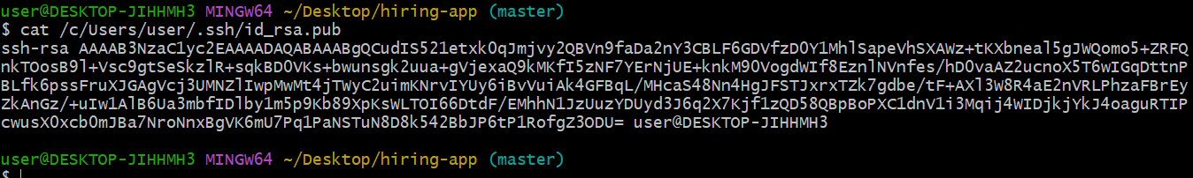

The above key copy without adding spaces

ssh-rsa  user@DESKTOP-JIHHMH3

goto github account>settings>scrolldown>and find >SSH and GPG Keys

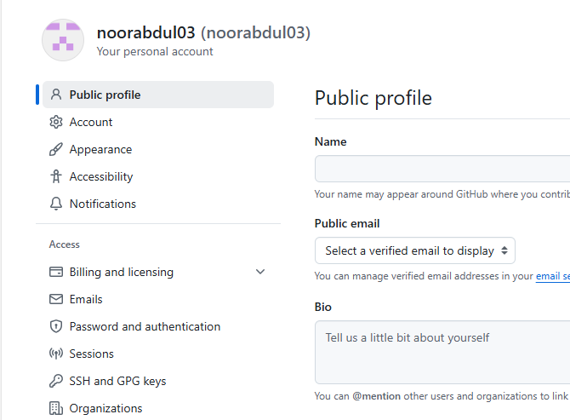

Click on ssh and GPG keys

Here click on New SSH key and add your ssh key details.



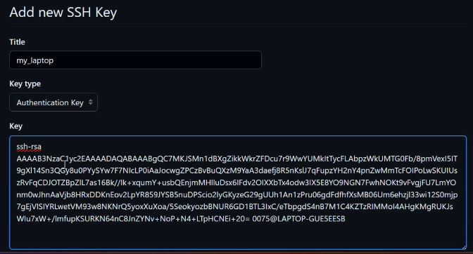

In our case it not case MFA but or example I have shown below saber’s

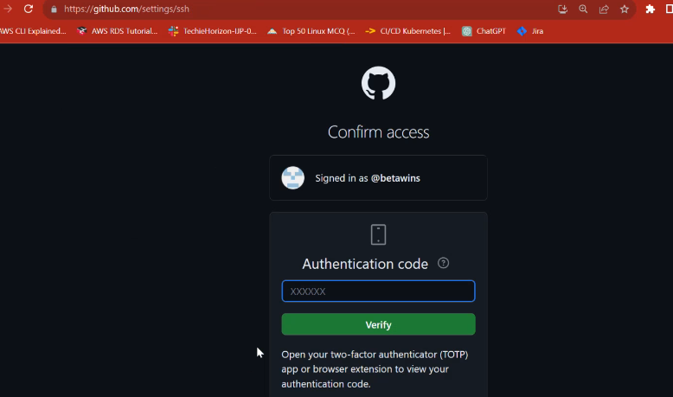

Once done you can see



Like this we have said to GIT that

This is the laptop trusted source who can push the code to this particular account.

And authentication happening based upon the SSH key.no need add username and password everytime

Goto repository again tech-horizon-06

As of now no code right

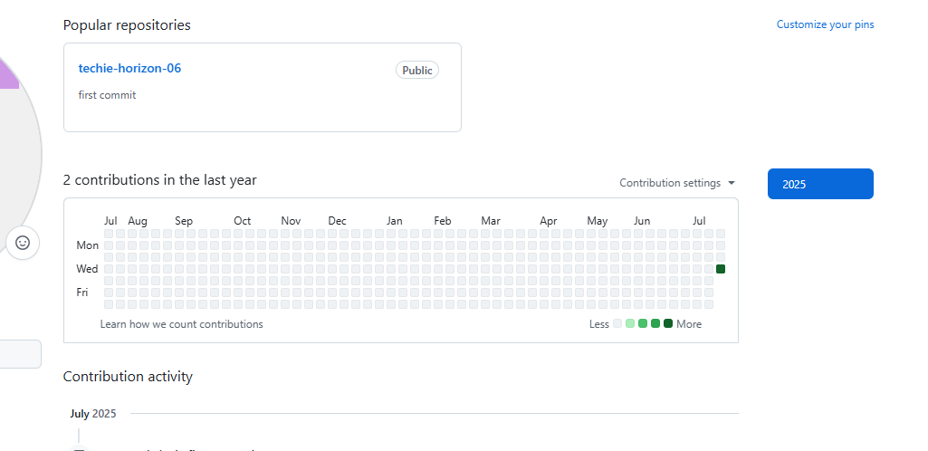

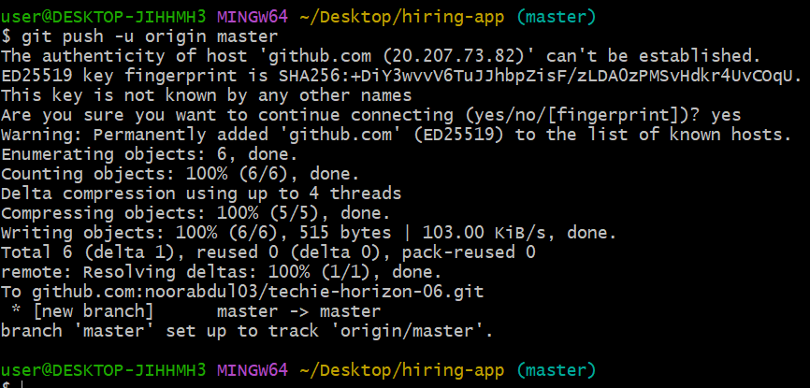

Goto CR page and refresh

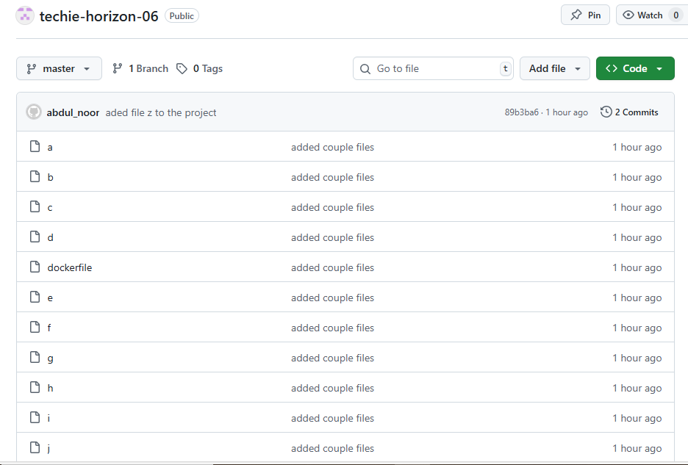



Now we have understood how to push the code from local to CR

Share the URL file

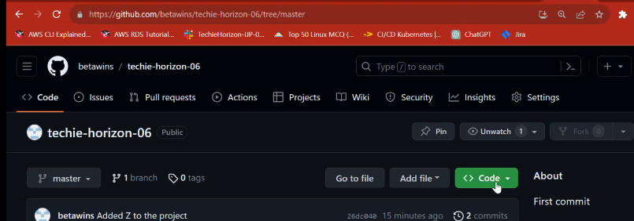

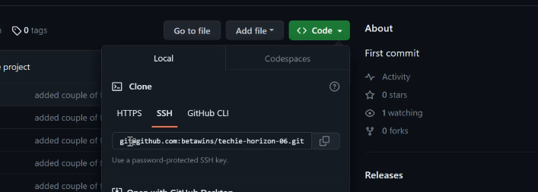

Copy the URL any HTTPS or SSH

And send it in slack to any account to whome you want send.

If the receiver click the from slack which is sent it will open and the receiver can access the code.

Example

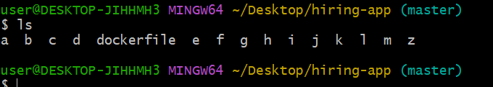

I want to delete this dockerfile

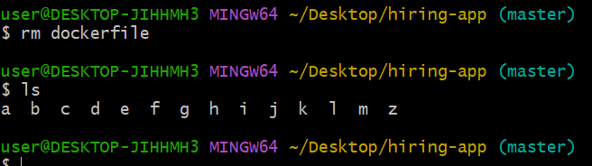

Now in the local machine dockerfile has been deleted

But from CR GITHUB it wont delete. That’s why we say istrubuted different different copys we have.one is in my LM one is in my CR

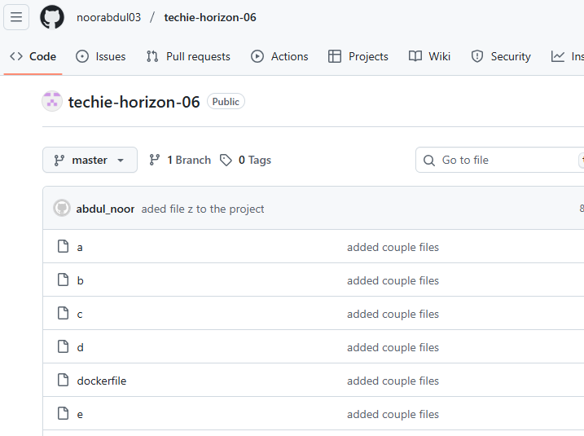

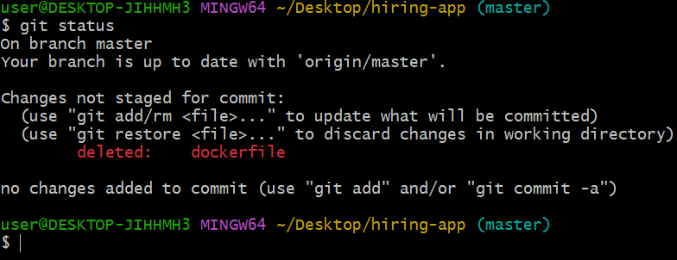

Now this is upated code bcz change happen by deletion activity.

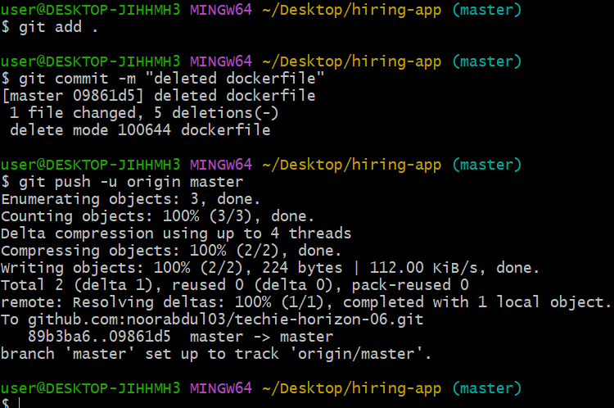

git commit -m "deleted dockerfile"

this will update yoor CR means your code was in Local only now I am trying push all my changes

do refresh you CR github

dockerfile will not appear

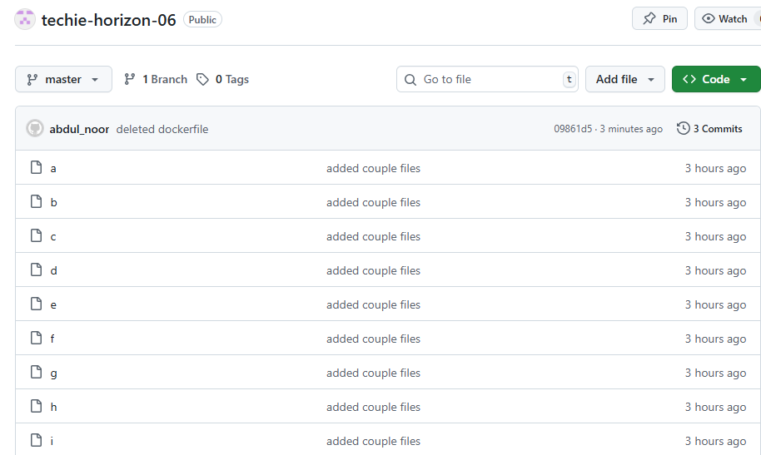

Example

Tajuddin team member made changes by adding a file in CR github then what will happen see

For this just add a file from CR

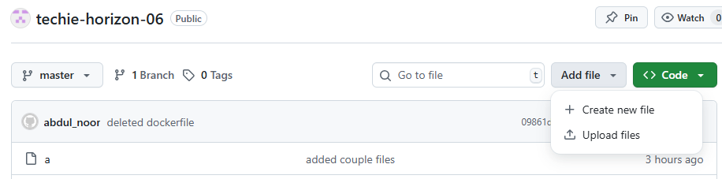

Here we gave details of file name tajuddinf and commit message also.

Commit changes

Commit changes



The tajuddinf file created in CR but don’t have in local machine.so it will not appear in LM

LS

Ok now I am creating some more files in my LM

Let us see what will happen if I do push from LM.

It will through the error. Bcz of tajuddinf created directly CR.So here GIT is working smartly and understanding that someone made changes in CR which is not available in my LM GIT. Means your LM and CR should always be same othervise it through the error.

What is the solution .

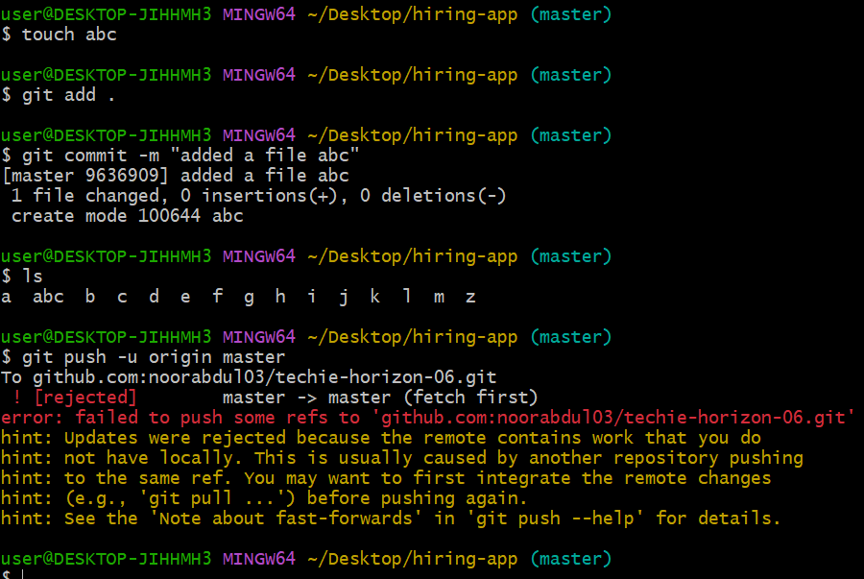

Now I need to pull the file tajuddinf into my LM from CR

To pull the command git pull

Will help to pull a file from CR

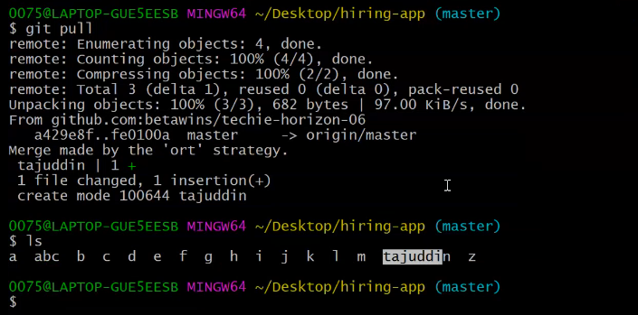

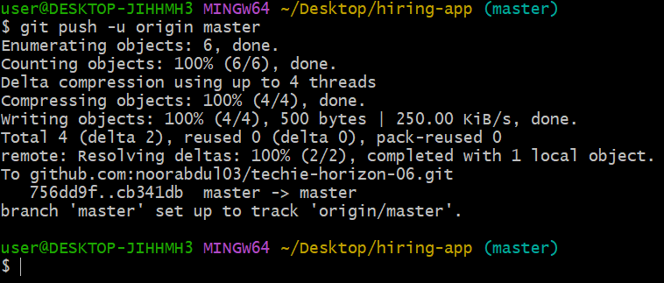

The do refresh CR

It will appear abc and tajuddinf

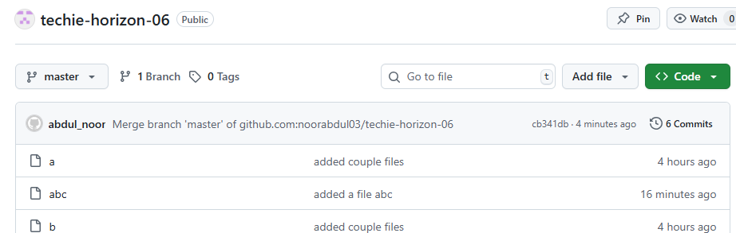

Example

I want to download the code from central to local

For paste Url rom CR beside git colon command.

To download the source code from CR to LM.

Git clone command help us to download the complete repository.

And git pull command help us to download the particular file.

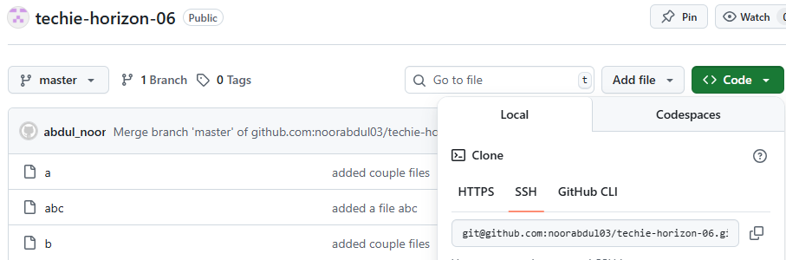

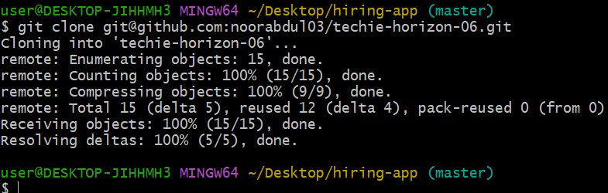

Do ls you can see the the directory added similar to our project name.

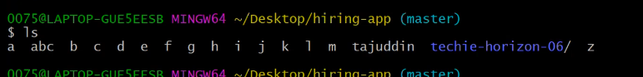

Get inside this directory

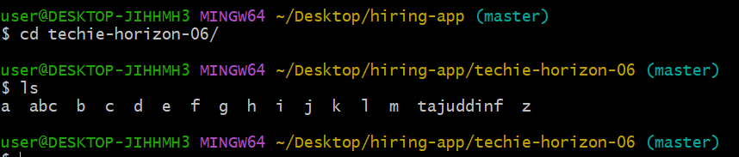

Okay

Come out from the directory

Example:

The prject which is on desktop deleted let see what will happen

Can I use git pull or git clone

Let see from git pull

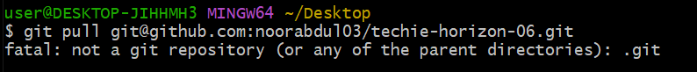

Git pull will not work for the first time pull will if you have already have any data related to your repository.

So you should use only git clone to download the project

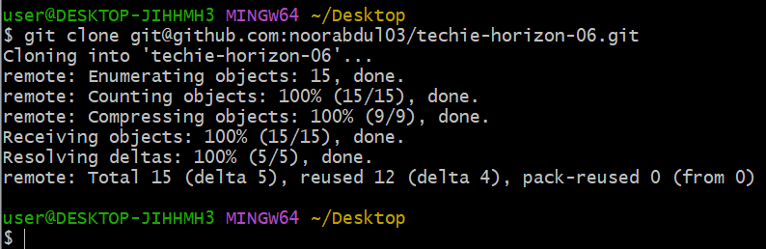

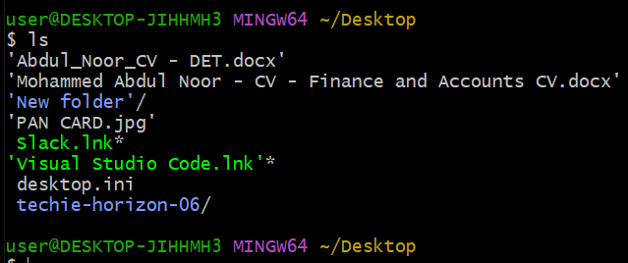

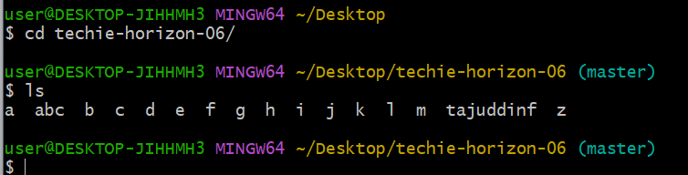

Now you can use git pull after added any file.

Example:

As I deleted the dockerile by rm dockerile

How can I get it

With the help git revert <commit_id>

How can I get the commit id

If use git log command it will display all the logs or I you use any number beside git log like

Git log -4 then it display the top 4 logs

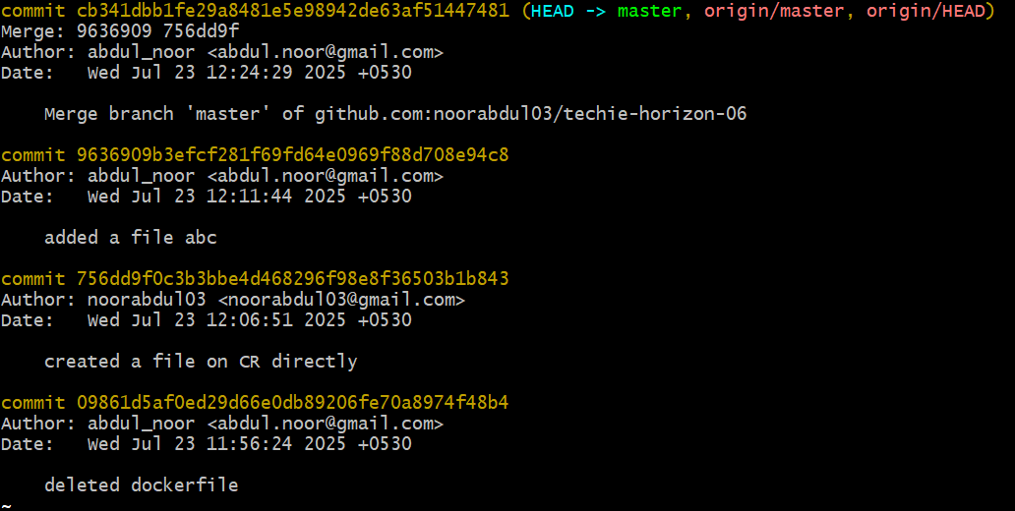

* this is my commit id

shit+q or exit



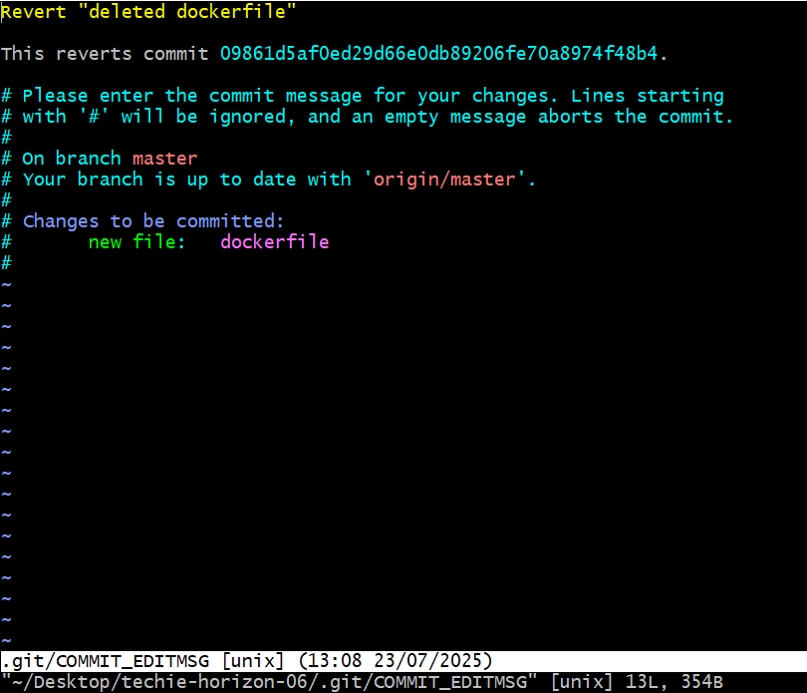

Just don’t do anything simply save it escape:wq!

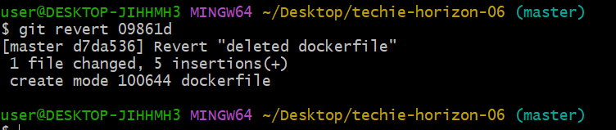

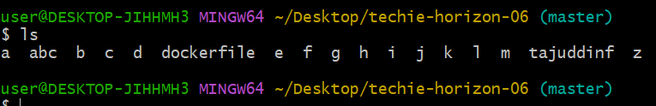

Now deleted dockerile has available

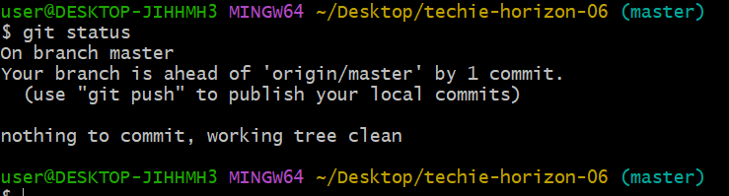

We don’t have any updates for commit

Example: moving back to untacking area from the tracking area.

Create a new file alphabet

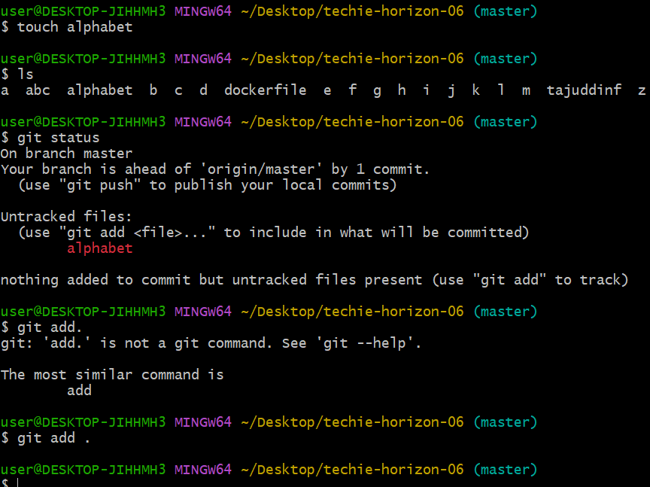

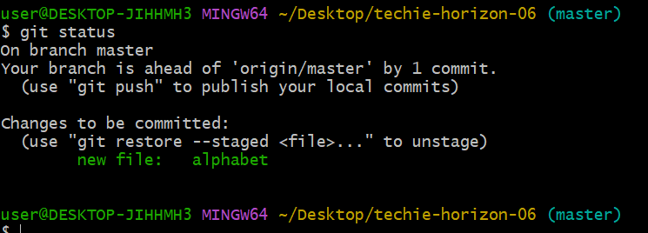

I don.t want to commit now bcz still lot of pending changes are there just want to move ut to t and you can only reset beore commit only. Ater commit you can only revert.

Git reset

